Student Enrollment and Course management system (SECMS)

PROJECT OVERVIEW:
The Student Enrollment and Course Management System is built on Salesforce to efficiently manage student admissions, course registrations, and enrollment processes in a centralized platform. It enables enrollment officers, instructors, and administrators to access and manage academic data with better visibility and control. The system uses automation features such as instructor assignment, validation rules, and approval workflows to streamline operations. Reports and dashboards provide real-time insights into enrollments, student status, and overall academic performance.
Introduction:
The Student Enrollment and Course
Management System is developed using Salesforce to simplify and organize the process of managing student admissions, courses, and enrollments. The system provides a centralized platform where enrollment officers, instructors, and administrators can easily access and manage academic data. By using Salesforce features such as Flows, Validation Rules, and Approval Processes, the system automates important tasks and ensures accurate data management. It also provides reports and dashboards to help monitor enrollment activities and improve decision-making.

Screen shots: • Salesforce developer account creation.
• A Salesforce Developer Account is a free account provided by Salesforce that allows users to learn, practice, and develop applications on the Salesforce platform. It provides access to various tools and features such as objects, flows, automation, reports, and dashboards. Developers and learners can use this account to build and test Salesforce applications without affecting real business data. It is mainly used for training, project development, and experimenting with Salesforce functionalities.
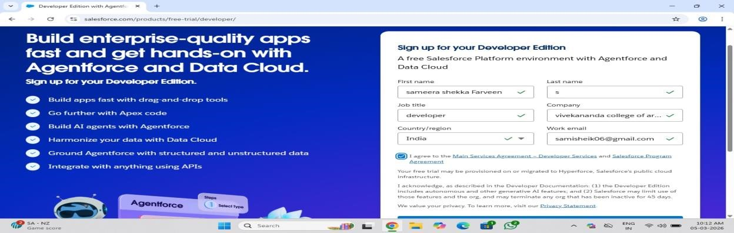

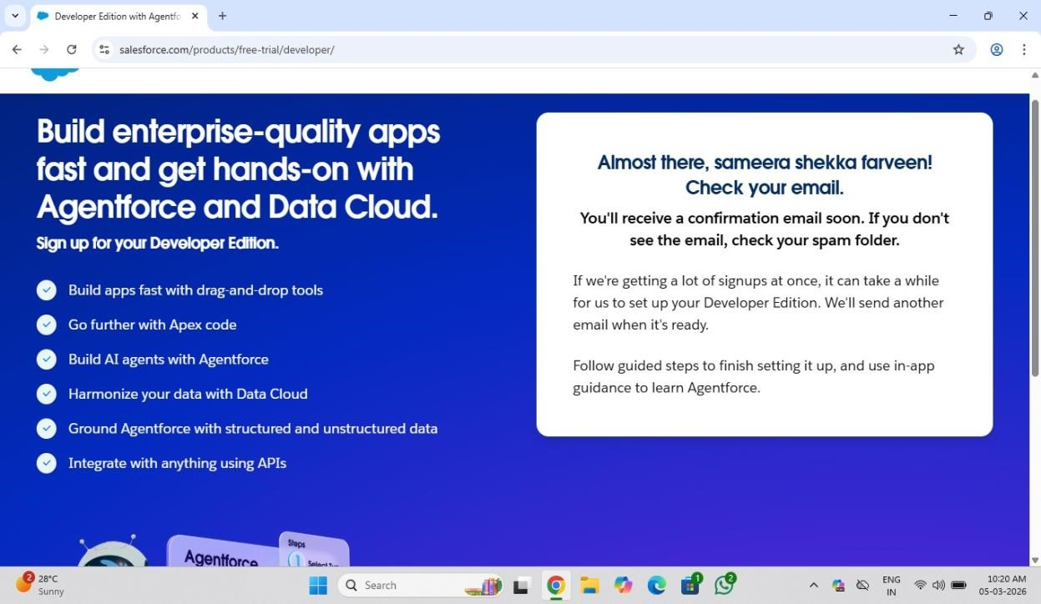

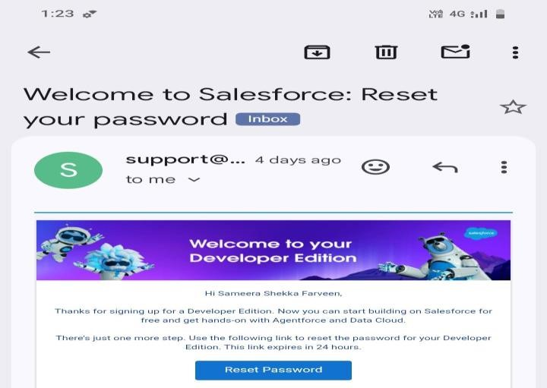

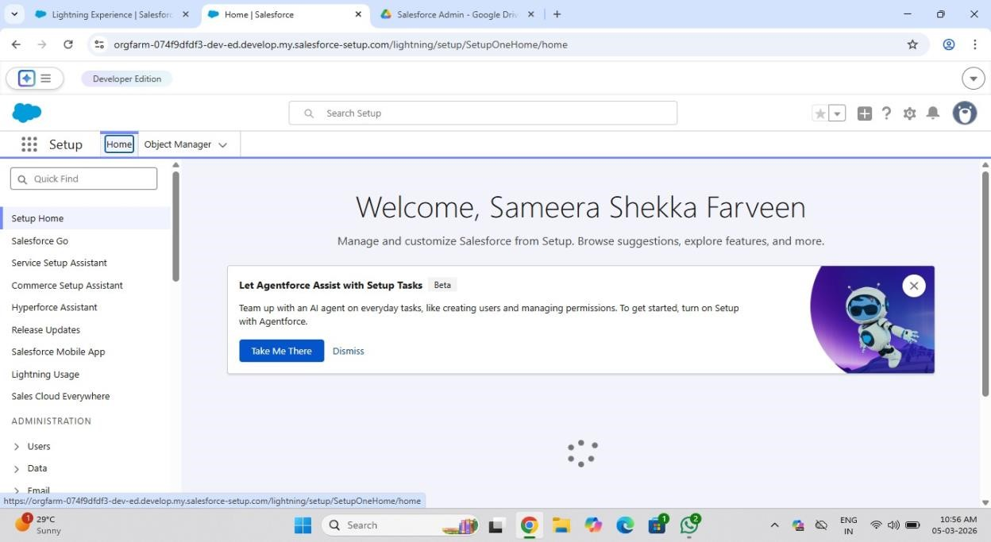

Fields – Fields are individual data elements used to store specific information in a record, such as Name, Email, or Phone Number. They help organize and manage data within an object.
Objects – Objects are database tables in Salesforce that store related data records.
Examples include Standard Objects like Account and Custom Objects created for specific business needs.
Reports – Reports are used to analyze and display data stored in Salesforce. They help users track records, monitor performance, and make informed decisions.
Flows – Flows are automation tools in
Salesforce used to automate business processes such as creating records, updating data, or assigning tasks automatically.
Emails – Emails in Salesforce are used to send automated notifications, alerts, or communication messages to users or customers based on specific actions or events.

Student – A student is an individual who enrolls in courses to gain knowledge or skills. In the system, student records store details such as name, contact information, and enrollment status.
Instructor – An instructor is a person responsible for teaching and guiding students in a particular course. In the system, instructor records maintain information such as instructor name, course assignment, and expertise area.

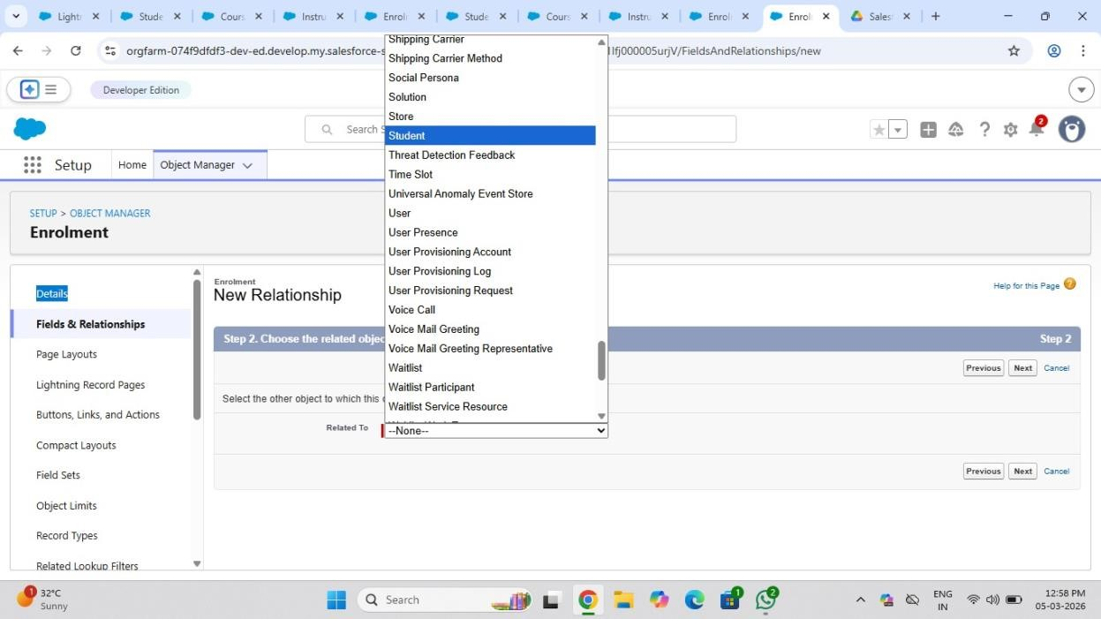

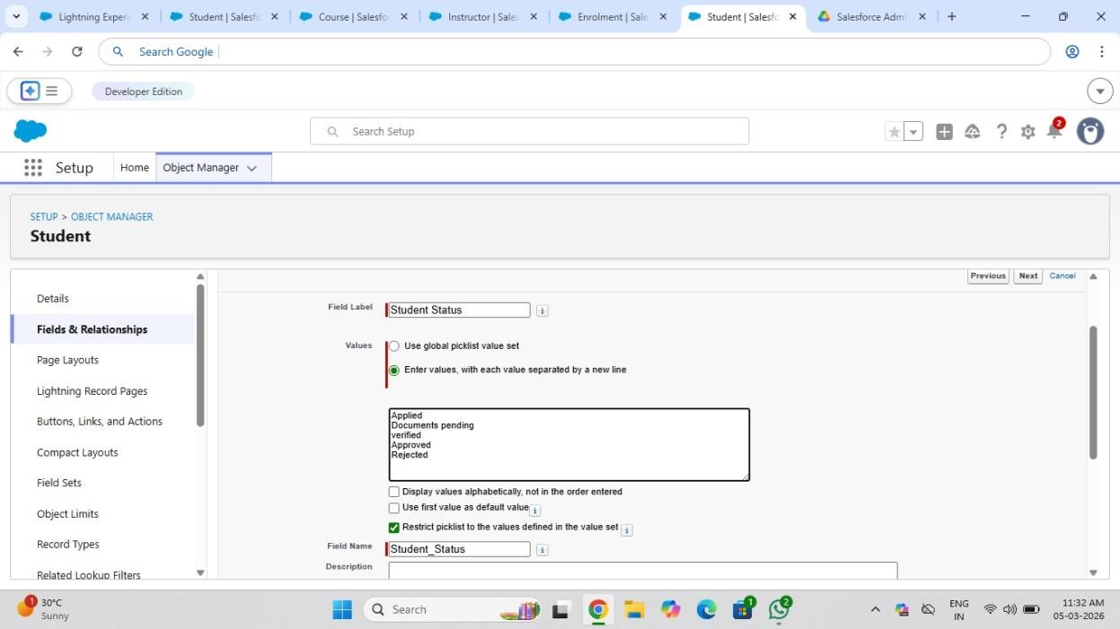

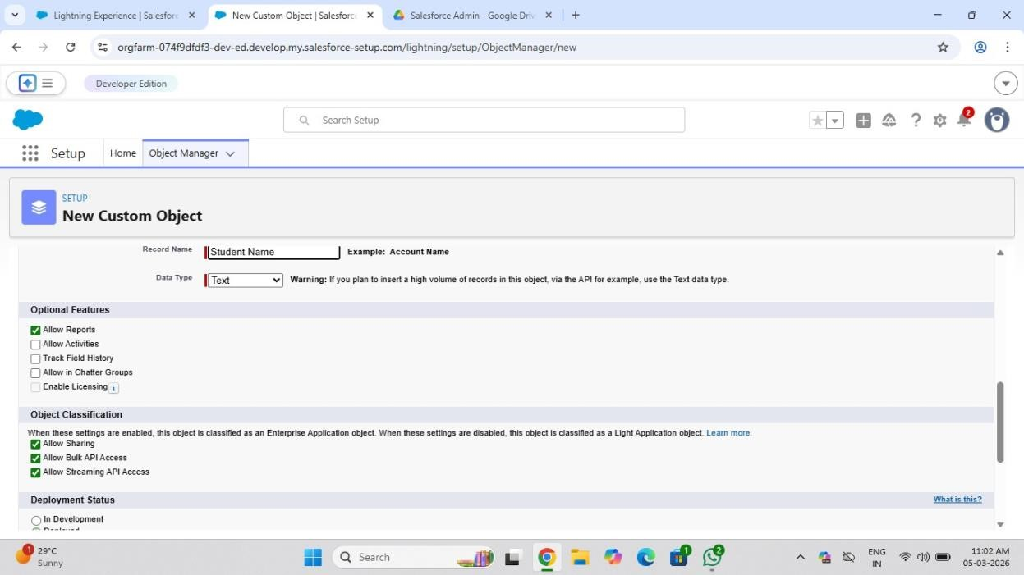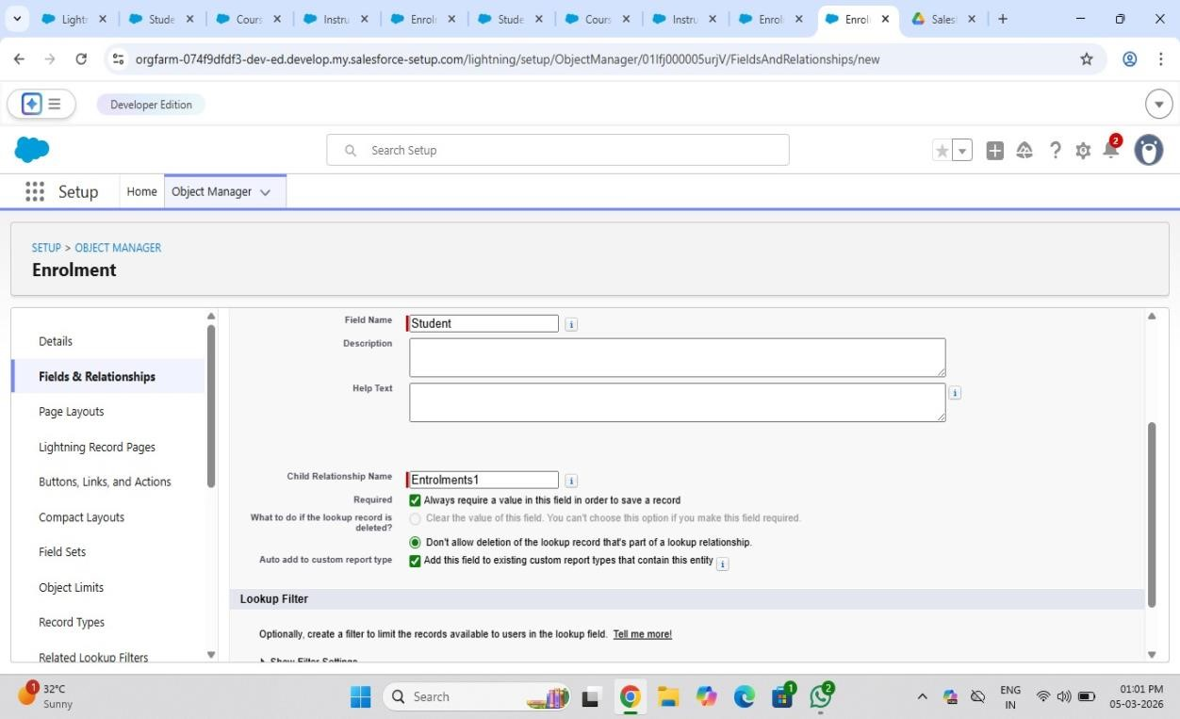
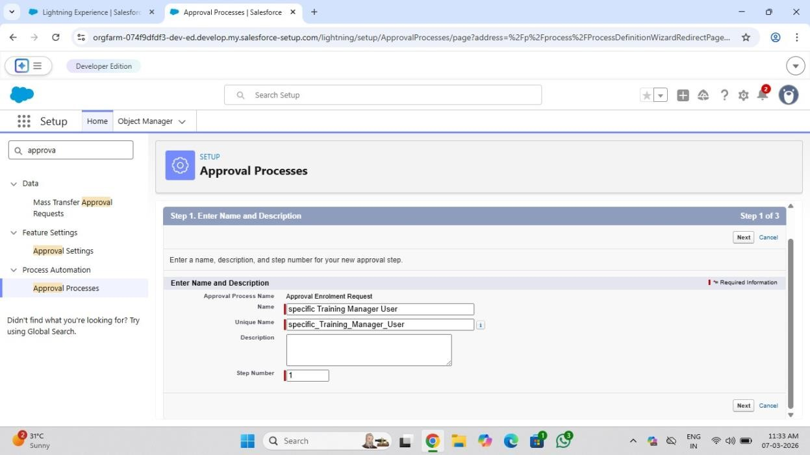

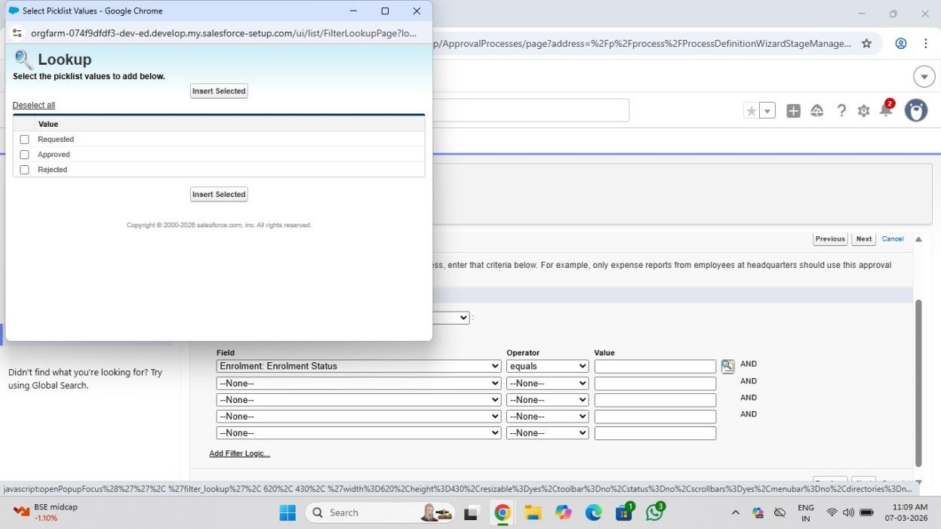

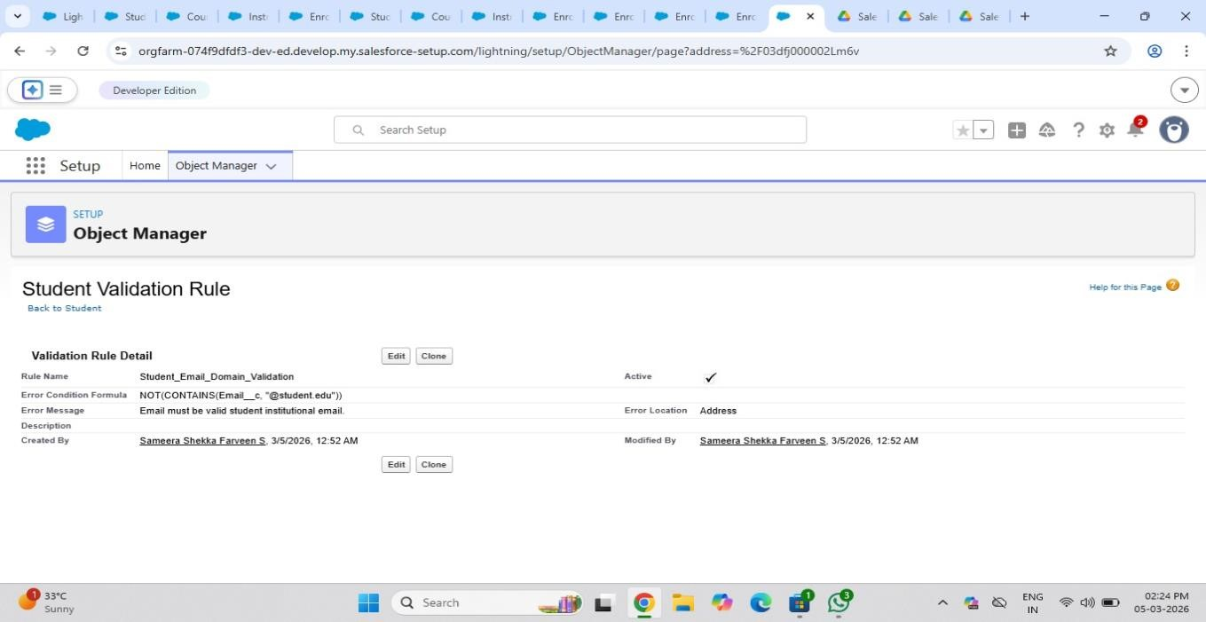

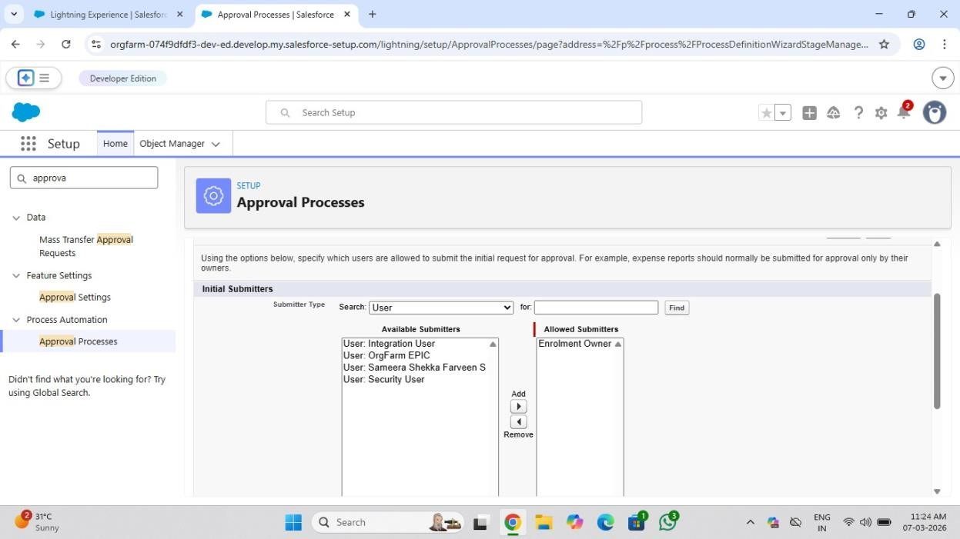


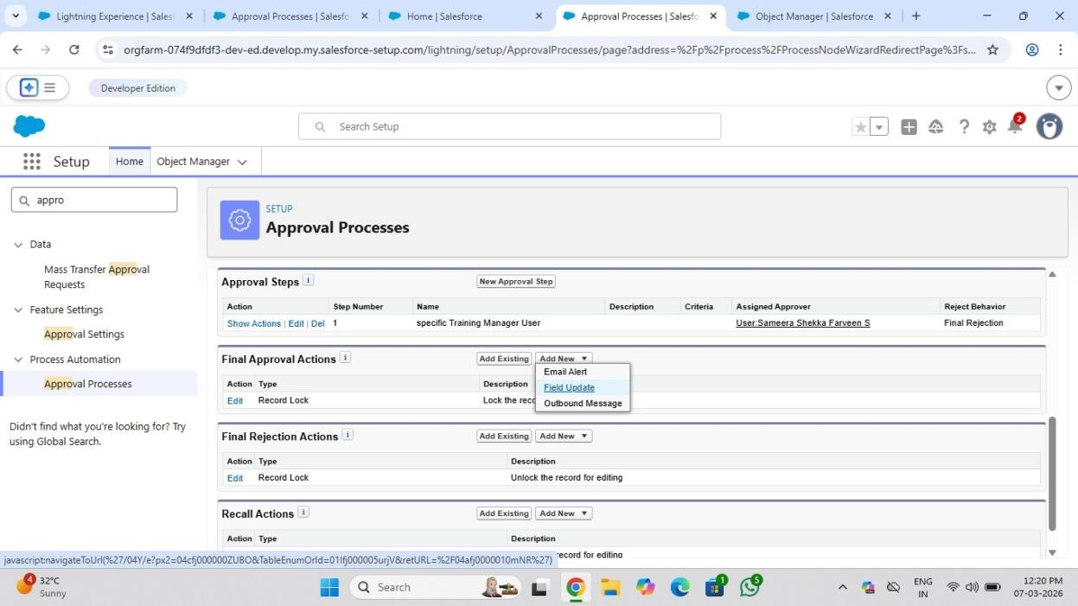

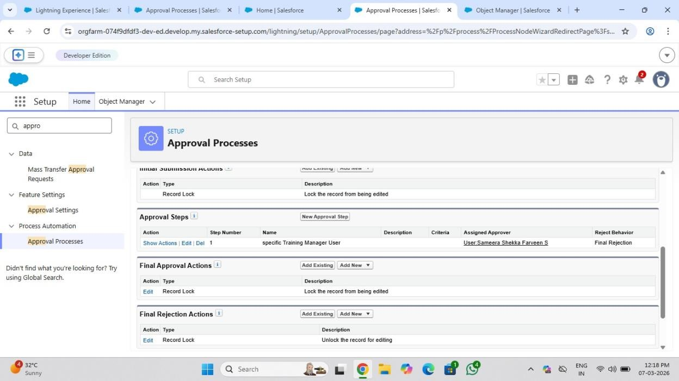

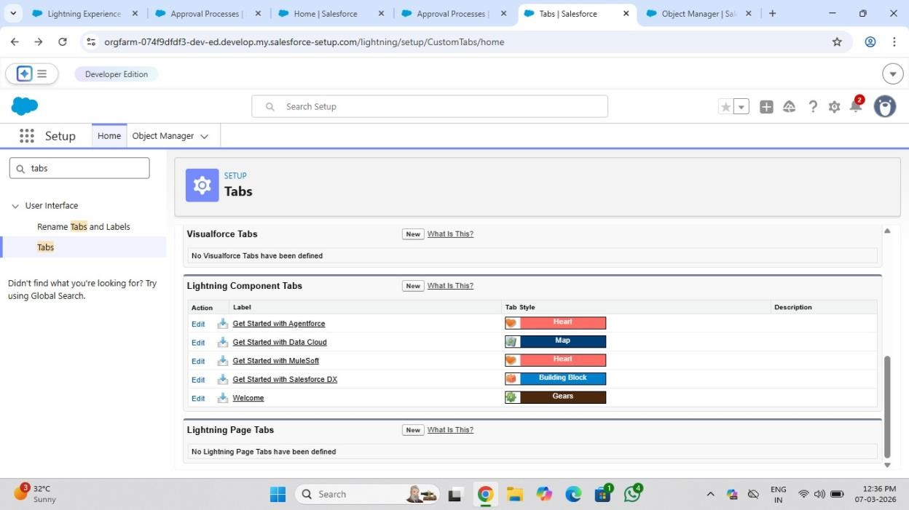

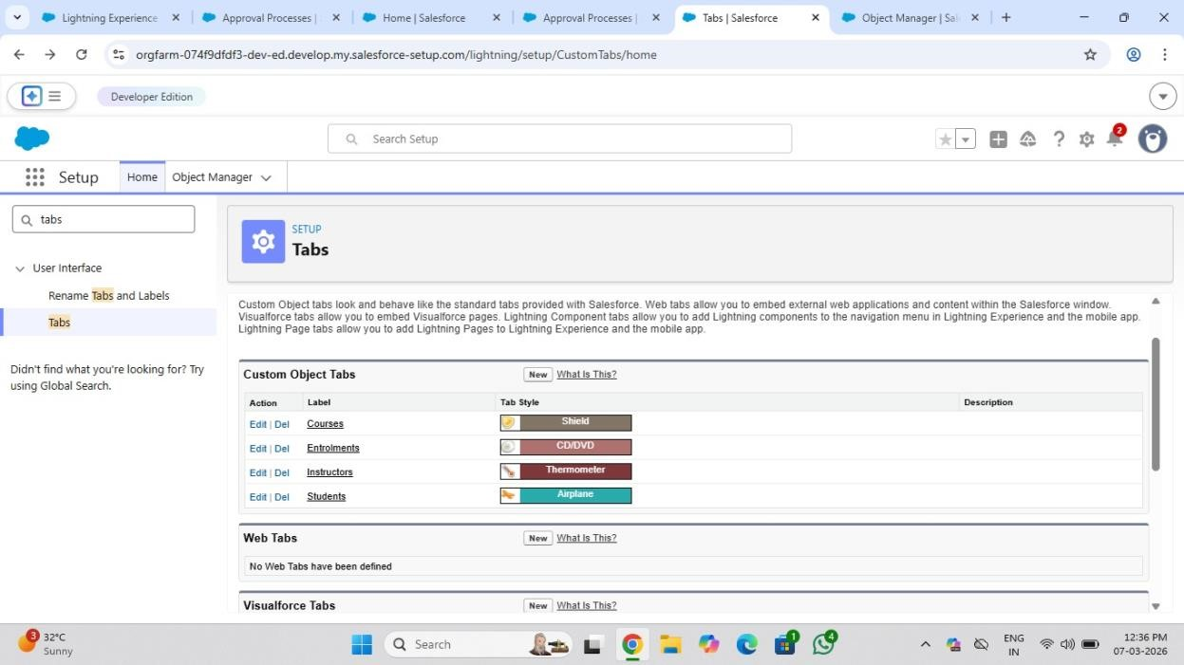

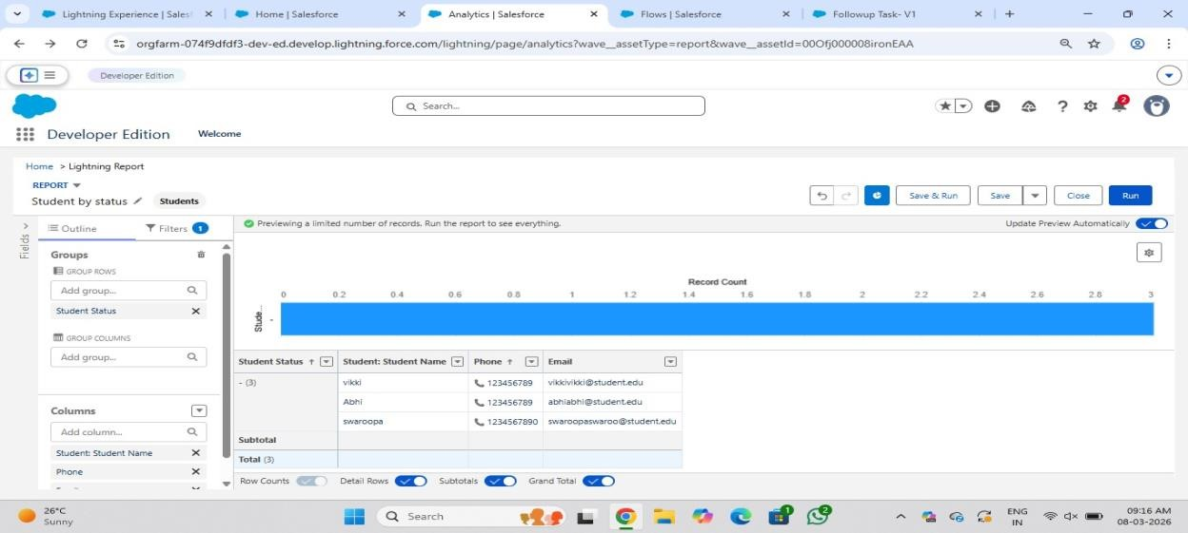
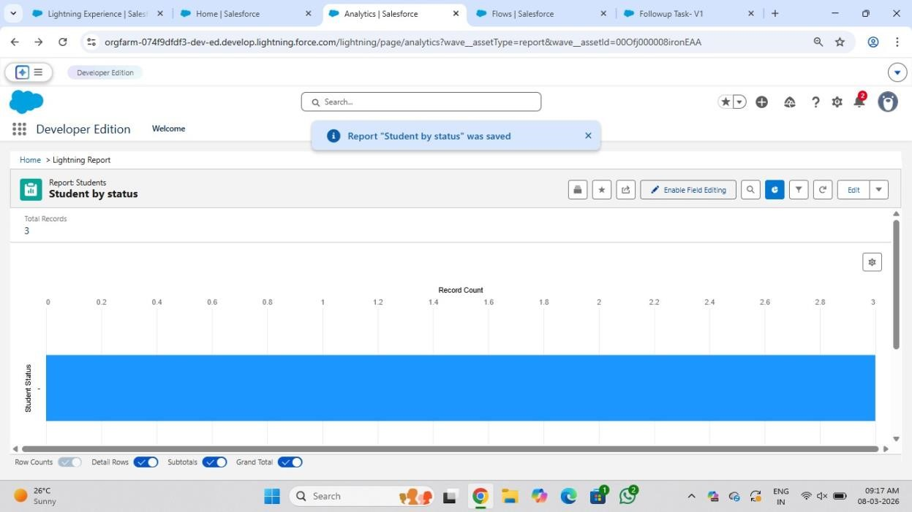

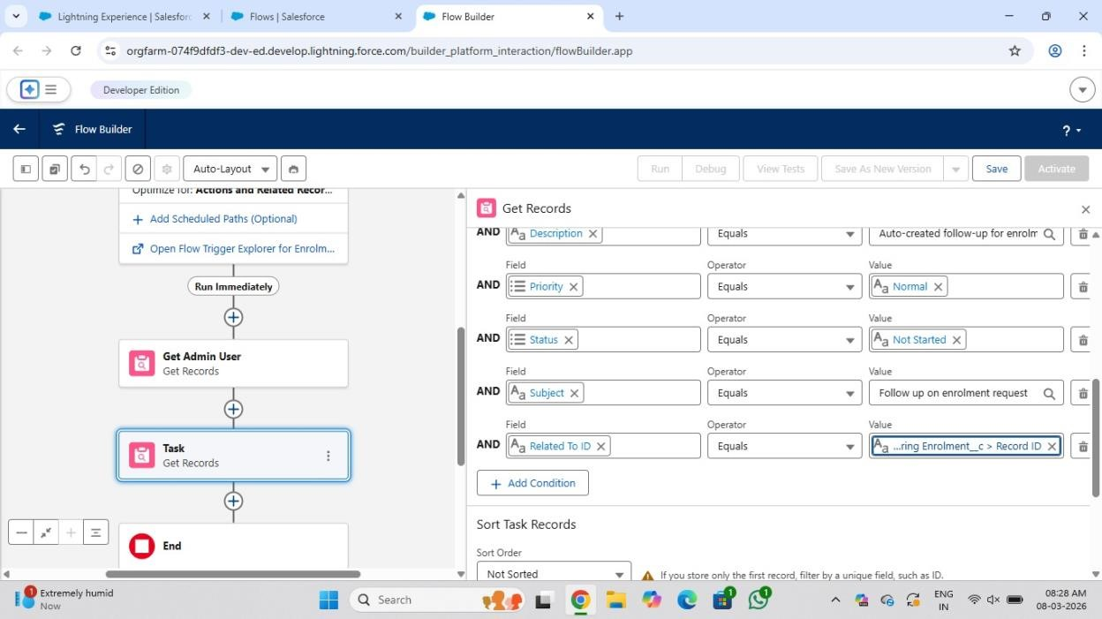

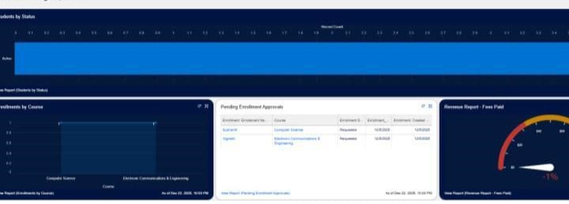

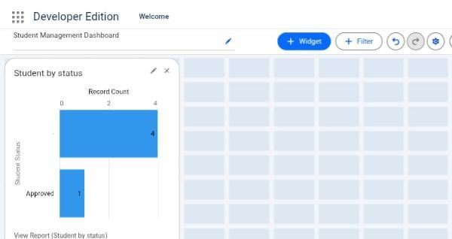

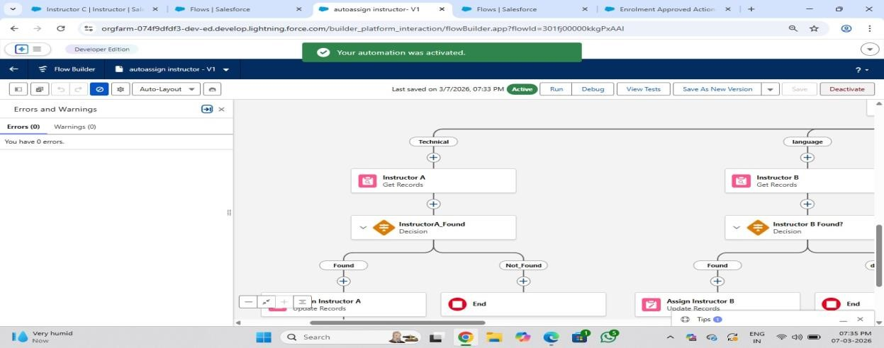

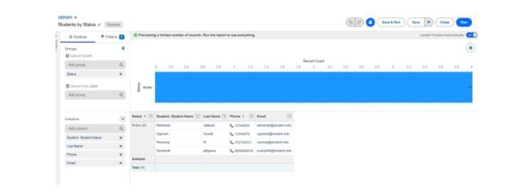

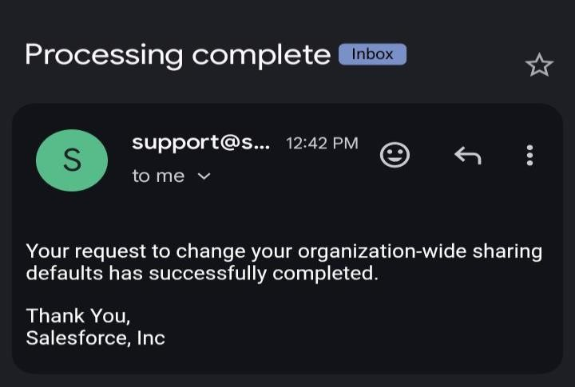

Conclusion
The Student Enrollment and Course Management System has been successfully developed using Salesforce to manage student, course, and enrollment information in an organized manner. The system improves efficiency through automation features such as flows, validation rules, and approval processes. It also provides better data visibility through reports and dashboards. Overall, the project successfully simplifies enrollment management and ensures smooth and effective academic operations.

